https://shorturl.at/G2IAP 6 Feb 2025
12 Feb 2025

G17 BEE
- Middlewares (All together)

Requirement
Static Files Handling: The server serves static files from the /public folder (HTML, CSS, JS). The index.html file is the entry point that users can interact with through their browser.
Routing: The /api routes handle requests:
- GET /api/greet/:name: Greets the user with their name.
- POST /api/echo: Echoes back any message sent in the body.
- GET /api/random: Returns a random number between 1 and 100.
Middleware:
- loggerMiddleware: Logs the request timestamp for every request.
- Third-party middlewares like morgan, helmet, and cors are applied for logging, security, and CORS handling respectively.
Frontend Interaction:
- The frontend allows users to input their name to get a personalized greeting, request a random number, or echo a message. Each action makes an API call to the backend, and the result is displayed in the #response section.
Exception Handling:
- 404 handler for unknown routes and a global error handler to manage unexpected issues.

<>
/public
/styles
- style.css
/js
- script.js
- index.html
/routes
- apiRoutes.js
/logger
- logger.js
- server.js

Initialyse the project
>npm init -y
Download the modules
>yarn add express morgan helmet cors body-parser --save

logger/logger.js
***logger.js***
// Application-level middleware to log request time
module.exports = (req, res, next) => {
console.log(`Request received at: ${new Date().toISOString()}`)
next() // Pass control to the next middleware
}

routes/apiRoutes.js
*** apiRoutes.js***
//?
const express = require('express')
//?
const router = express.Router()
// Route handler for GET /api
router.get('/', (req, res) => {
res.json({ message: 'Welcome to the API' })
})
// Route handler for GET /api/greet/:name
router.get('/greet/:name', (req, res) => {
const name = req.params.name
res.json({ message: `Hello, ${name}` })
})
// Route handler for POST /api/echo (echoes the posted data)
router.post('/echo', (req, res) => {
const data = req.body
res.json({ message: 'Here is your data', data })
})
// Route handler for GET /api/random (returns a random number)
router.get('/random', (req, res) => {
const randomNumber = Math.floor(Math.random() * 100) + 1
res.json({ randomNumber })
})
//?
module.exports = router

***server.js***
//?
const express = require('express')
const morgan = require('morgan')
const bodyParser = require('body-parser')
const helmet = require('helmet')
const cors = require('cors')
const path = require('path')
const loggerMiddleware = require('./logger/logger') // Application level middleware
const apiRoutes = require('./routes/apiRoutes') // Routing middleware
//?
const app = express()
// Set the port as 8080
const PORT = 8080
//How will you use the third party middlewares ?
app.use(morgan('tiny')) // Log every request to the console
app.use(helmet()) // Add security headers
app.use(cors()) // Enable CORS for all requests

// Application level middleware (for logging)
app.use(loggerMiddleware)

// Built-in middleware for parsing JSON bodies
app.use(bodyParser.json())
/*
// Serve static files (HTML, CSS, JS)
app.use(express.static(path.join(__dirname, 'public')))
*/
// Routing middleware: routes are in a separate file
app.use('/api', apiRoutes)
// Error handling middleware for 404 (not found)
app.use((req, res, next) => {
res.status(404).send('Page not found')
})
// Global error handler for unexpected issues
app.use((err, req, res, next) => {
console.error(err.stack)
res.status(500).send('Something went wrong!')
})
// Start the server on the specified port
app.listen(PORT, () => {
console.log(`Server running on port ${PORT}`)
})

At this stage test application in postman, and then design user interface

a. GET Request to /api
- URL: http://localhost:8080/api
- Method: GET
- Expected Response: A JSON object with a welcome message.
{
"message": "Welcome to the API"
}
b. GET Request to /api/greet/:name
- URL: http://localhost:8080/api/greet/students
- Method: GET
- Expected Response: A JSON object with a personalized greeting message.
{
"message": "Hello, students"
}
c. POST Request to /api/echo
- URL: http://localhost:8080/api/echo
- Method: POST
- Body:
  - Choose raw and set the type to JSON.
  - Enter a JSON object to echo back, for example:
{
"University": "Chitkara",
"Dept": "CSE"
}
- Expected Response: A JSON object with the same data you sent.
{
"message": "Here is your data",
"data": {
"University": "Chitkara",
"Dept": "CSE"
}
}

{
"University": "Chitkara",
"Dept": "CSE",
age:25
}
It will be 500 error
d. GET Request to /api/random
- URL: http://localhost:8080/api/random
- Method: GET
- Expected Response: A JSON object with a random number between 1 and 100.
{
"randomNumber": 42
}

Error Handling
If you test a route that doesn't exist, for example /api/unknown, you should get a 404 error:
- Response: Page not found
Global Error Handling
If there's a server error, like an uncaught exception, you'll see a generic error message:
- Response: Something went wrong!

Testing Middlewares all together Video Link:- https://shorturl.at/ouszF

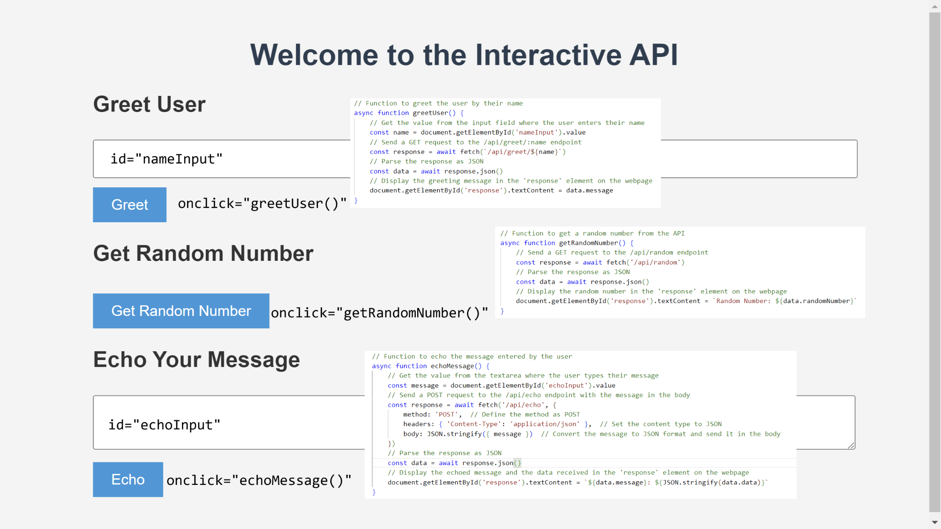
public/index.html
***index.html***
<!DOCTYPE html>
<html lang="en">

<head>
<meta charset="UTF-8">
<meta name="viewport" content="width=device-width, initial-scale=1.0">
<title>Interactive API</title>
<link rel="stylesheet" href="styles/style.css">
</head>

<body>
<div class="container">
<h1>Welcome to the Interactive API</h1>
<div id="response"></div>

<section>
<h2>Greet User</h2>
<input type="text" id="nameInput" placeholder="Enter your name">
<button onclick="greetUser()">Greet</button>
</section>

<section>
<h2>Get Random Number</h2>
<button onclick="getRandomNumber()">Get Random Number</button>
</section>

<section>
<h2>Echo Your Message</h2>
<textarea id="echoInput" placeholder="Write something to echo"></textarea>
<button onclick="echoMessage()">Echo</button>
</section>
</div>
<script src="./js/script.js"></script>

</body>

</html>

public/js/script.js
***script.js***
// Function to greet the user by their name
async function greetUser() {
// Get the value from the input field where the user enters their name
const name = document.getElementById('nameInput').value

// Send a GET request to the /api/greet/:name endpoint
const response = await fetch(`http://localhost:8080
/api/greet/${name}`)

// Parse the response as JSON
const data = await response.json()

// Display the greeting message in the 'response' element on the webpage
document.getElementById('response').textContent = data.message
}

// Function to get a random number from the API
async function getRandomNumber() {
// Send a GET request to the /api/random endpoint
const response = await fetch('http://localhost:8080
/api/random')

// Parse the response as JSON
const data = await response.json()

// Display the random number in the 'response' element on the webpage
document.getElementById('response').textContent = `Random Number: ${data.randomNumber}`
}

// Function to echo the message entered by the user
async function echoMessage() {
// Get the value from the textarea where the user types their message
const message = document.getElementById('echoInput').value

// Send a POST request to the /api/echo endpoint with the message in the body
const response = await fetch('http://localhost:8080
/api/echo', {
method: 'POST', // Define the method as POST
headers: { 'Content-Type': 'application/json' }, // Set the content type to JSON
body: JSON.stringify({ message }) // Convert the message to JSON format and send it in the body
})

// Parse the response as JSON
const data = await response.json()

// Display the echoed message and the data received in the 'response' element on the webpage
document.getElementById('response').textContent = `${data.message}: ${JSON.stringify(data.data)}`
}

public/styles/style.css
***style.css***
/* Basic styling for the interactive API page */
body {
font-family: Arial, sans-serif;
background-color: #f4f4f4;
color: #333;
margin: 0;
padding: 0;
}

.container {
width: 80%;
margin: 0 auto;
padding: 20px;
}

h1 {
text-align: center;
color: #2c3e50;
}

section {
margin: 20px 0;
}

input,
textarea {
width: 100%;
padding: 10px;
margin-top: 5px;
font-size: 16px;
}

button {
background-color: #3498db;
color: white;
padding: 10px 20px;
border: none;
cursor: pointer;
font-size: 16px;
margin-top: 10px;
}

button:hover {
background-color: #2980b9;
}

#response {
margin-top: 20px;
font-size: 18px;
font-weight: bold;
color: #27ae60;
}

